Tutorial – 1

- Write a program to print “Hello World”.

using System;
using System.Collections.Generic;
using System.Linq;
using System.Text;
using System.Threading.Tasks;

namespace _24SOECE13901_SAURAV_PANDIT_Tutorial_1
{
internal class Q1
{
static void Main()
{
Console.WriteLine("Hello World");
}
}
}

Output:

- Design your profile page as given below.

namespace _24SOECE13901_SAURAV_PANDIT_Tutorial_1
{
internal class Q2
{
static void Main()
{
Console.WriteLine("Name: Saurav Pandit");
Console.WriteLine("DOB: 20/11/2005");
Console.WriteLine("Address: 8, Manda Dungar, Aji Dam");
Console.WriteLine("City: Rajkot");
Console.WriteLine("Pincode: 360 003");
Console.WriteLine("State: Gujarat");
Console.WriteLine("Country: India");
Console.WriteLine("Email: srv@gmail.com");
}
}
}

Output:

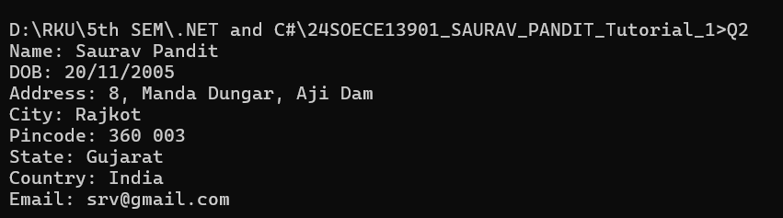

- Find out whether the given number is odd or even.

namespace _24SOECE13901_SAURAV_PANDIT_Tutorial_1
{
internal class Q3
{
static void Main()
{
Console.Write("Enter a number: ");
int number = Convert.ToInt32(Console.ReadLine());

if (number % 2 == 0)
{
Console.WriteLine(number + " is Even.");
}
else
{
Console.WriteLine(number + " is Odd.");
}
}
}
}

Output:

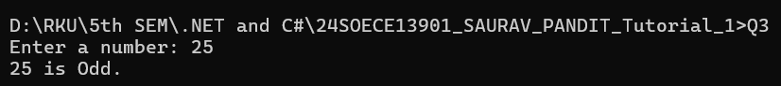

- Rearrange the given code to correct the program. The resultant program will be to input a number and print whether the given number is odd or even.

namespace _24SOECE13901_SAURAV_PANDIT_Tutorial_1
{
internal class Q4
{
static void Main(string[] args)
{
int x;
string str;

Console.WriteLine("Enter Number: ");
str = Console.ReadLine();

x = Convert.ToInt32(str);

if (x % 2 == 0)
Console.WriteLine("Number is Even");
else
Console.WriteLine("Number is Odd");

Console.Read();
}
}
}

Output:

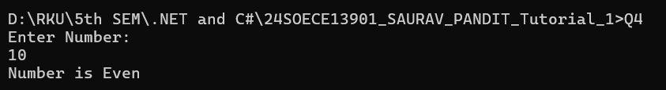

- Write output of the program. Also write comment for each line for the following code.

namespace _24SOECE13901_SAURAV_PANDIT_Tutorial_1
{
internal class Q5
{
static void Main(string[] args)
{
int n, fact = 1;

Console.WriteLine("Enter Number : ");

string str = Console.ReadLine();

n = Convert.ToInt32(str);

for (int i = 1; i <= n; i++)
{
fact = fact * i;
}

Console.WriteLine("Factorial : {0}", fact);

Console.Read();
}
}
}

0utput:

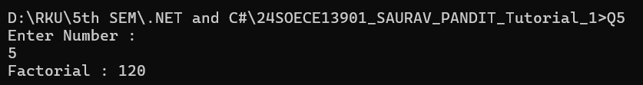

- Write missing statement to get the desired output.

namespace _24SOECE13901_SAURAV_PANDIT_Tutorial_1
{
internal class Q6
{
static void Main(string[] args)
{
int a, b, c, result;
string str;

Console.Write("Enter Number 1: ");
str = Console.ReadLine();
a = Convert.ToInt32(str);

Console.Write("Enter Number 2 : ");
str = Console.ReadLine();
b = Convert.ToInt32(str);

Console.Write("Enter Number 3 : ");
str = Console.ReadLine();
c = Convert.ToInt32(str);

result = Sum(a, b, c);
Console.WriteLine("Sum : " + result);

Console.Read();
}

static int Sum(int x, int y, int z)
{
int res;
res = x + y + z;
return res;
}
}
}

Output:

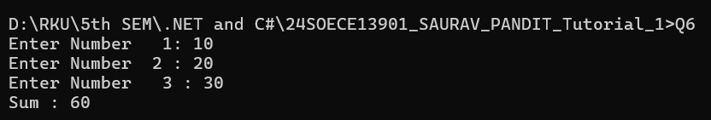

- Predict and write the output of the given code.

Output:

Enter a number
5

Enter a number
5 x 1 = 5
5 x 2 = 10
5 x 3 = 15
5 x 4 = 20
5 x 5 = 25
5 x 6 = 30
5 x 7 = 35
5 x 8 = 40
5 x 9 = 45
5 x 10 = 50

- Write a program to convert given name in upper characters.

namespace _24SOECE13901_SAURAV_PANDIT_Tutorial_1
{
internal class Q8
{
static void Main(string[] args)
{
string name;

Console.Write("Enter your name: ");
name = Console.ReadLine();

string upperName = name.ToUpper();

Console.WriteLine("Output: " + upperName);

Console.ReadLine();
}
}
}

Output:

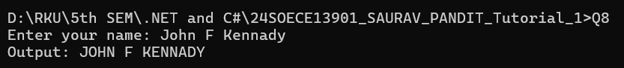

- Write a Program to convert given name in toggle case.

namespace _24SOECE13901_SAURAV_PANDIT_Tutorial_1
{
internal class Q9
{
static void Main(string[] args)
{
string name, toggleName = "";

Console.Write("Enter your name: ");
name = Console.ReadLine();

foreach (char ch in name)
{
if (char.IsUpper(ch))
toggleName += char.ToLower(ch);
else if (char.IsLower(ch))
toggleName += char.ToUpper(ch);
else
toggleName += ch; // For spaces or symbols
}

Console.WriteLine("Output: " + toggleName);

Console.ReadLine();
}
}
}

Output:

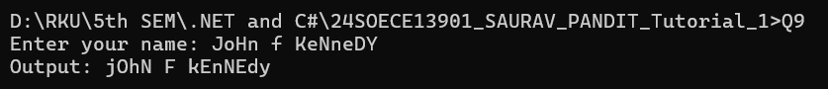

- Write a Program which accepts mobile no as a string from the user and converts the last 5 digits into X.

namespace _24SOECE13901_SAURAV_PANDIT_Tutorial_1
{
internal class Q10
{
static void Main(string[] args)
{
string mobile;

Console.Write("Enter your mobile number: ");
mobile = Console.ReadLine();

if (mobile.Length >= 5)
{
string masked = mobile.Substring(0, mobile.Length - 5) + "XXXXX";
Console.WriteLine("Output: " + masked);
}
else
{
Console.WriteLine("Invalid mobile number. Must be at least 5 digits.");
}

Console.ReadLine();
}
}
}

Output:

- Write a Program which accepts name and gender from the user. Here, gender may have only 1 character, M or F.

namespace _24SOECE13901_SAURAV_PANDIT_Tutorial_1
{
internal class Q11
{
static void Main(string[] args)
{
string name;
char gender;

Console.Write("Enter your name: ");
name = Console.ReadLine();

Console.Write("Enter your gender (M/F): ");
gender = Convert.ToChar(Console.ReadLine().ToUpper());

if (gender == 'M')
{
Console.WriteLine("Output: Mr. " + name);
}
else if (gender == 'F')
{
Console.WriteLine("Output: Ms. " + name);
}
else
{
Console.WriteLine("Invalid gender input. Please enter M or F.");
}

Console.ReadLine();
}
}
}

Output:

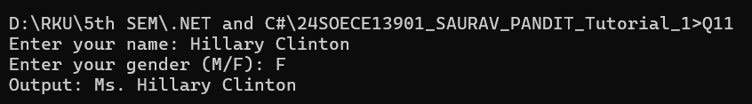

- Write a Program which accepts name from the user and prints the same

namespace _24SOECE13901_SAURAV_PANDIT_Tutorial_1
{
internal class Q12
{
static void Main(string[] args)
{
string name;

Console.Write("Enter your name: ");
name = Console.ReadLine();

Console.WriteLine("Output: " + name);

Console.ReadLine();
}
}
}

Output:

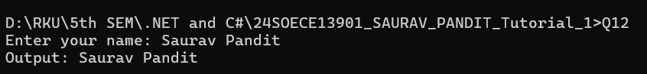

- Write a Program to prints the following series
0 1 1 2 3 5 8 13 21 34 55

namespace _24SOECE13901_SAURAV_PANDIT_Tutorial_1
{
internal class Q13
{
static void Main(string[] args)
{
int a = 0, b = 1, c;

Console.Write(a + " " + b + " ");

while (true)
{
c = a + b;
if (c > 55)
break;

Console.Write(c + " ");
a = b;
b = c;
}

Console.ReadLine();
}
}
}

Output:

- Write a Program which accepts no from the user and print the same in words.

namespace _24SOECE13901_SAURAV_PANDIT_Tutorial_1
{
internal class Q14
{
static void Main(string[] args)
{
Console.Write("Enter a number: ");
string number = Console.ReadLine();

foreach (char digit in number)
{
switch (digit)
{
case '0': Console.Write("Zero "); break;
case '1': Console.Write("One "); break;
case '2': Console.Write("Two "); break;
case '3': Console.Write("Three "); break;
case '4': Console.Write("Four "); break;
case '5': Console.Write("Five "); break;
case '6': Console.Write("Six "); break;
case '7': Console.Write("Seven "); break;
case '8': Console.Write("Eight "); break;
case '9': Console.Write("Nine "); break;
default: Console.Write("? "); break;
}
}

Console.ReadLine();
}
}
}

Output:

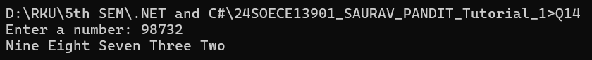

- Write a Program to check whether the given no is Armstrong no or not.

namespace _24SOECE13901_SAURAV_PANDIT_Tutorial_1
{
internal class Q15
{
static void Main(string[] args)
{
int number, originalNumber, remainder, result = 0, digits = 0;

Console.Write("Enter a number: ");
number = Convert.ToInt32(Console.ReadLine());
originalNumber = number;

int temp = number;
while (temp != 0)
{
temp /= 10;
digits++;
}

temp = number;
while (temp != 0)
{
remainder = temp % 10;
result += (int)Math.Pow(remainder, digits);
temp /= 10;
}

if (result == originalNumber)
Console.WriteLine(originalNumber + " is an Armstrong number.");
else
Console.WriteLine(originalNumber + " is not an Armstrong number.");

Console.ReadLine();
}
}
}

Output:

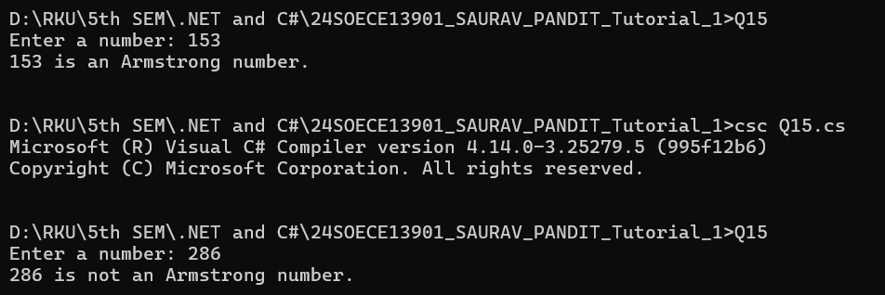

- Write a program to display a pattern like a right angle triangle using an asterisk.

namespace _24SOECE13901_SAURAV_PANDIT_Tutorial_1
{
internal class Q16
{
static void Main(string[] args)
{
for (int i = 1; i <= 4; i++)
{
for (int j = 1; j <= i; j++)
{
Console.Write("*");
}
Console.WriteLine();
}

Console.ReadLine();
}
}
}

Output:

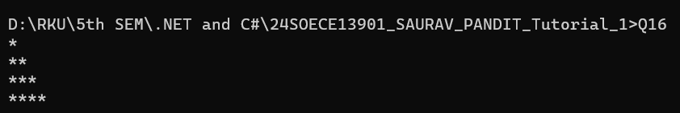

- Write a Program to generate following output.

namespace _24SOECE13901_SAURAV_PANDIT_Tutorial_1
{
internal class Q17
{
static void Main(string[] args)
{
for (int i = 1; i <= 4; i++)
{
for (int j = 1; j <= i; j++)
{
Console.Write(j + " ");
}
Console.WriteLine();
}

Console.ReadLine();
}
}
}

Output:
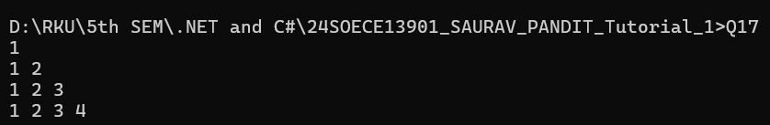

- Write a program to make such a pattern like a right angle triangle with the number increased by 1.

namespace _24SOECE13901_SAURAV_PANDIT_Tutorial_1
{
internal class Q18
{
static void Main(string[] args)
{
int num = 1;

for (int i = 1; i <= 4; i++)
{
for (int j = 1; j <= i; j++)
{
Console.Write(num + " ");
num++;
}
Console.WriteLine();
}

Console.ReadLine();
}
}
}

Output:

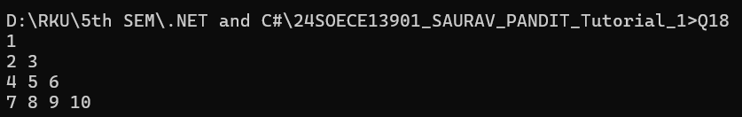

- Write a program to make such a pattern as a pyramid with an asterisk.

namespace _24SOECE13901_SAURAV_PANDIT_Tutorial_1
{
internal class Q19
{
static void Main(string[] args)
{
int rows = 4;

for (int i = 1; i <= rows; i++)
{
for (int space = 1; space <= rows - i; space++)
{
Console.Write(" ");
}

for (int star = 1; star <= i; star++)
{
Console.Write("* ");
}

Console.WriteLine();
}

Console.ReadLine();
}
}
}

Output:

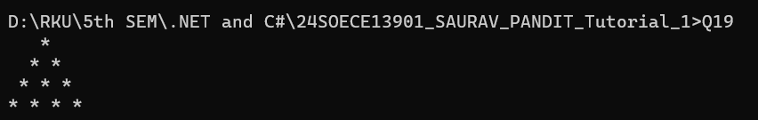

- Write a program to make a pyramid pattern with numbers increased by 1.

namespace _24SOECE13901_SAURAV_PANDIT_Tutorial_1
{
internal class Q20
{
static void Main(string[] args)
{
int rows = 4;
int num = 1;

for (int i = 1; i <= rows; i++)
{
for (int space = 1; space <= rows - i; space++)
{
Console.Write(" ");
}

for (int j = 1; j <= i; j++)
{
Console.Write(num + " ");
num++;
}

Console.WriteLine();
}

Console.ReadLine();
}
}
}

Output:

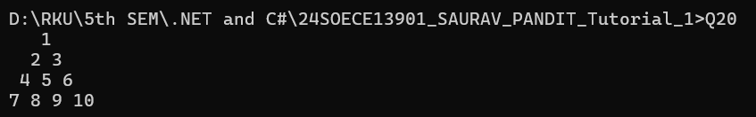

- Write a program to find the sum of the series 5 +55 + 555 + 5555 + .. n terms.

namespace _24SOECE13901_SAURAV_PANDIT_Tutorial_1
{
internal class Q21
{
static void Main(string[] args)
{
int n, digit;

Console.Write("Input the number of terms: ");
n = Convert.ToInt32(Console.ReadLine());

Console.Write("Input number: ");
digit = Convert.ToInt32(Console.ReadLine());

int term = 0;
int sum = 0;

Console.Write("Series: ");

for (int i = 1; i <= n; i++)
{
term = term * 10 + digit;
sum += term;

Console.Write(term);
if (i != n)
Console.Write(" + ");
}

Console.WriteLine();
Console.WriteLine("The Sum is : " + sum);

Console.ReadLine();
}
}
}

Output:

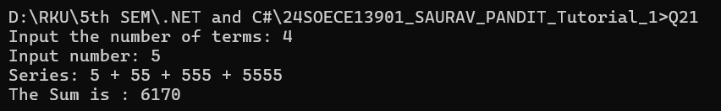

- Write a program to display a pattern like a diamond.

namespace _24SOECE13901_SAURAV_PANDIT_Tutorial_1
{
internal class Q22
{
static void Main(string[] args)
{
int n = 5;

for (int i = 1; i <= n; i++)
{
for (int space = 1; space <= n - i; space++)
{
Console.Write(" ");
}

for (int star = 1; star <= 2 * i - 1; star++)
{
Console.Write("*");
}

Console.WriteLine();
}

for (int i = n - 1; i >= 1; i--)
{
for (int space = 1; space <= n - i; space++)
{
Console.Write(" ");
}

for (int star = 1; star <= 2 * i - 1; star++)
{
Console.Write("*");
}

Console.WriteLine();
}

Console.ReadLine();
}
}
}

Output:

